1- List windows Service

2- remove program manually

Remove program manually, some program doesn’t go form remove program

- REGEDIT in the Run
- HKEY_LOCAL_MACHINE\SOFTWARE\Microsoft\Windows\CurrentVersion\Uninstall

- Now click on the Uninstall key in the left panel, click on the Registry menu, and select Export Registry file. A convenient place to store this file is your Desktop; you can call it Uninstall.reg. You are doing this in order to be able to restore the Registry the way it was before (by importing the file Uninstall.reg) in case your Registry editing screws things up.

3- msconfig

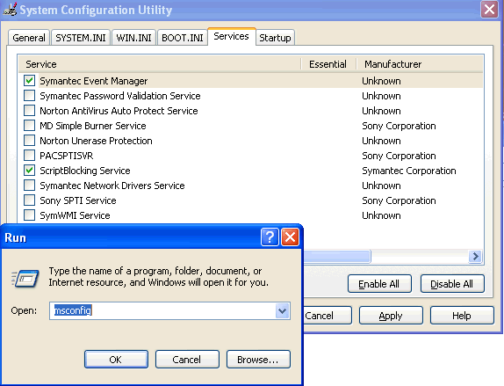

4- Share Folder

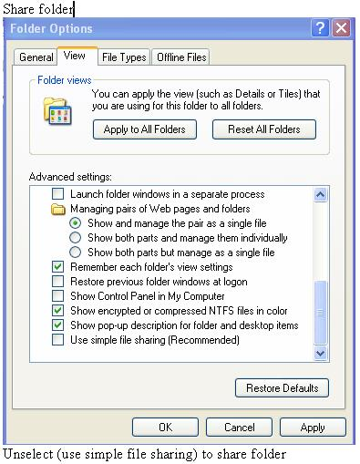
5- send message to computer

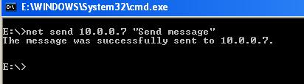

6- Remove hidden program

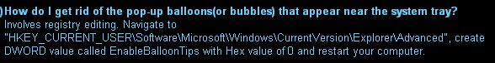
7- remove balloon from start menu

8- Allow remote desktop connection

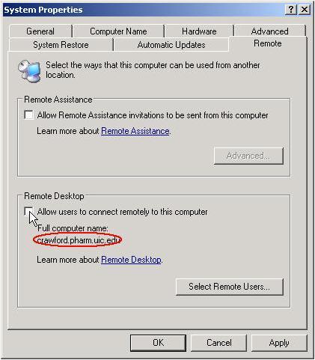

9- No password at login
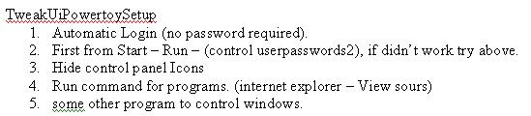
10- Enable routing on windows
Enable routing on windows

7. Start the registry editor (Regedit.exe) and set HKEY_LOCAL_MACHINE\SYSTEM\CurrentControlSet\ Services\Tcpip\Parameters\IPEnableRouter to 1.
This step enables IPv4 routing between Subnet 2 and Subnet 3.
11- Allow communication between computers (SP2)
Configure Windows to allow communication between client computers
1. Click Start, point to Control Panel, and then click Security Center.
2. Click Windows Firewall, and then in the Windows Firewall dialog box, click the Advanced tab.
3. Click Settings for ICMP, and then click Allow incoming echo request.
4. Click OK twice to close Windows Firewall.
12- Disable Internal Speaker
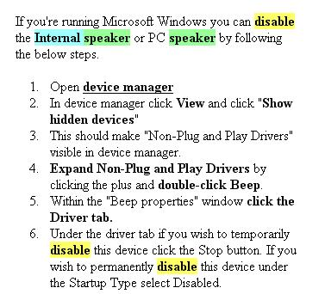
13- Disable Error report
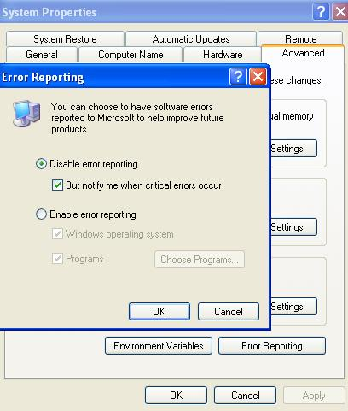

14- Delete temp files

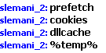

15- Clear internet textbox
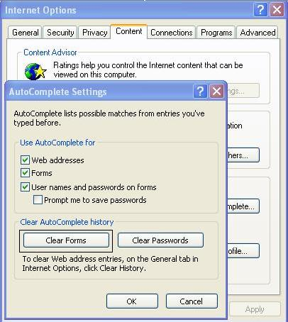

16- Auto save word documents
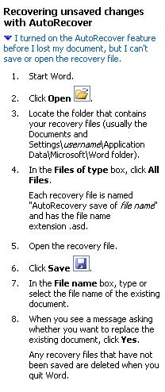
17- autoexec PATH

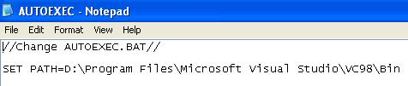

18- 2003 enable game, graphic other services

Index of /ranj.amin/rawand/IT info/game directx on server
Name Last modified Size Description

Parent Directory 10-May-2007 17:58 -
1.jpg 05-Aug-2006 11:58 51k
2.jpg 05-Aug-2006 11:58 48k
How to convert your ..> 05-Aug-2006 11:58 8k
How to convert your ..> 05-Aug-2006 11:58 -
Thumbs.db 05-Aug-2006 11:58 25k
shutdown.htm 05-Aug-2006 11:58 8k
shutdown_files/ 05-Aug-2006 11:58 -

- 19- Stop windows messenger at boot up
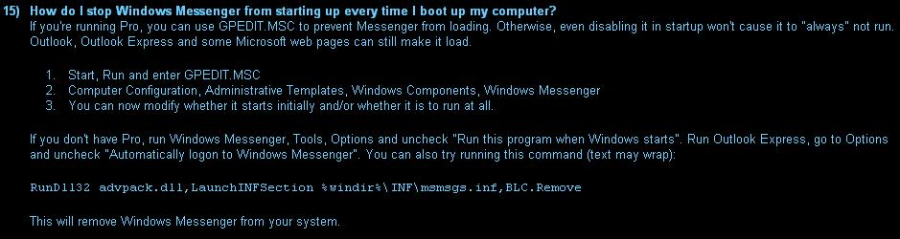

- Shutdown PC

Download soft ware

