گرفتن ایمیج ویندو با گوست
Making an image of your hard disk using Norton Ghost
- Insert CD
- Press Number 6 on keyboard
- Then hit enter when see 1
- Type A then hit enter
- You will see D:\ then type a:\ hit enter
- Type: A:\go.exe hit enter
Norton Ghost is an exceptionally useful utility which allows you to create an "image" of your hard disk, which can be stored on a network server or cd-rom.
This "image" contains a full carbon copy of your entire hard disk, or selected partition so that if the unthinkable happens, and your pc dies through either terminal crash, or disk failure, you can dump your entire operating system back onto disk without the need for time consuming installation of OS, drivers and software.
This article is intended as a straightforward guide to using ghost, and while it may not cover every permutation of ghost's usage, it hopefully will give you some helpful guidelines as to it's operation.
Getting Started
Ghost is not a windows program, and can be used to image many different operating systems, such as Windows 98, 2000, XP and even Linux.
Because ghost is not designed to run under your normal operating system, you will need to boot your machine from an dos based floppy disk. There are several steps involved in ensuring your machine boots from your floppy disk, rather than hard disk or cd rom.
1. Set your boot priority.
Your computer's BIOS (Basic Input/Output System) is a piece of "hard wired" software, which provides support for your computers peripherals, such as hard disks, cd-rom drives, and memory, and helps your OS to function correctly. In order to access it, you will more than likely need to press either the <DEL> or <F2> keys during your machine's initial start up sequence.
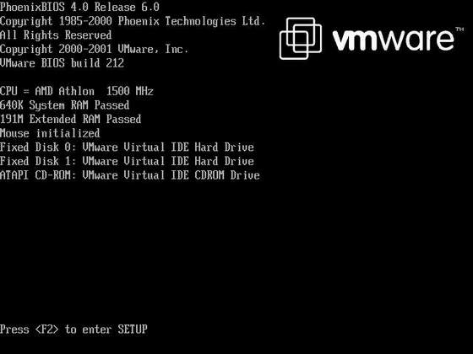
It is often best to press this key (or combination of keys) while the computer is performing it's memory tests.
Once you have managed to correctly enter the computer's bios, you will be presented with several menu's covering everything from hard disk setup, through to power saving and processor configuration.
A word of warning!
Unless you absolutely know what you are doing, it is a good idea to avoid changing anything that you are not familiar with here. The bios is a very powerful piece of software, and changing anything, no matter how inconsequential it may seem, can have far ranging effects on the operation of your machine, even going so far as preventing it from starting up at all.
Different brands of computer use different type of bios, for example Award BIOS, Ami Bios & Phoenix Bios.
Shown below is a screenshot taken from a Phoenix Bios:
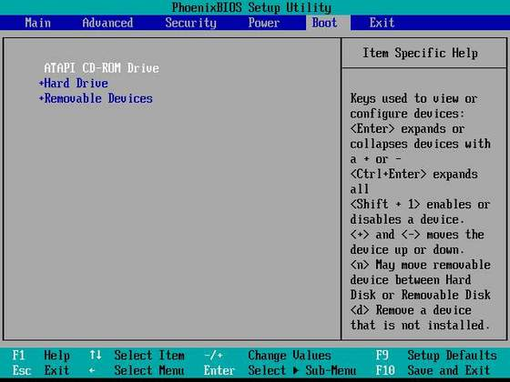
As you can see, the present "boot priority" of this machine will cause the pc to attempt to boot from the cd-rom first, then the hard disk, and finally from removable drives, such as the floppy disk, or if installed a zip drive.
What you need to do here, is change that boot priority, so that the machine boots from the floppy disk before any other device.
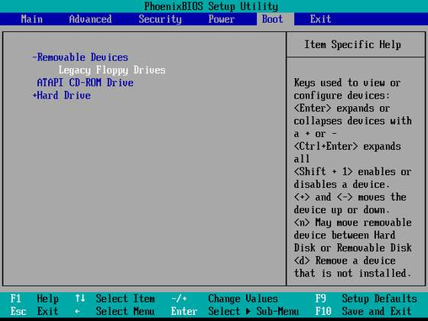
Having successfully changed the boot priority, you should exit from your bios menu, ensuring that you save the changes you made. You should be prompted to do so.
Here is an example of the boot priority settings from an AMI BIOS :
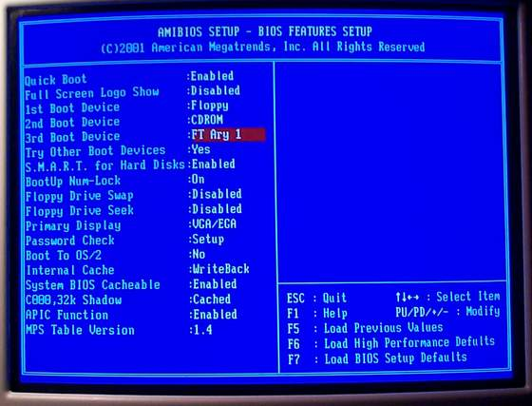
The "FT Ary 1" menu item that you can see in the above screen shot, simply describes the type of hard disk in this particular system (a raid array), but under normal use, you should see "hard disk", or "ide-0" as one of your choices.
prev< | >next

Making an image of your hard disk using Norton Ghost - Page 2
2. Booting From floppy disk.
Now that you have set your computer to boot from the floppy disk drive first, you need to have a suitable disk prepared.
Those of you using Windows 98, or Windows ME can create a suitable boot disk simply by formatting a floppy disk through Windows Explorer, remembering to check the "Copy system files" box before you start.
Another good way of creating a boot floppy is downloading a self executing boot disk writer such as this.
If you have created a full boot floppy (such as a windows 98 startup disk), you will probably need to have a second blank disk handy for the ghost program to run from. If you can, copy a mouse driver to this floppy disk as well, so that navigation through ghost's menu is made easier. The latest version of the Microsoft DOS mouse driver is available in winzip format from here.
To start ghost, simply eject the boot floppy, insert the disk you copied ghost.exe and your mouse driver to, and type :
mouse , followed by ghost
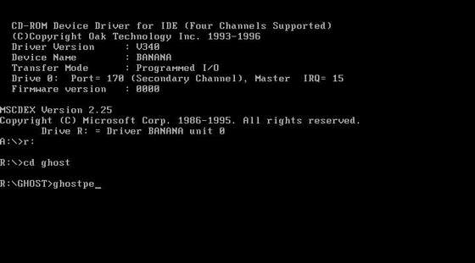
In the above screenshot, i have changed to drive R: in order to load ghost off a utilities cd-rom which i use. If you have copied ghost onto a floppy, you should stay on drive A: and start ghost from there.
3. Making your image.
Once ghost has loaded, you will be presented with a screen like this :
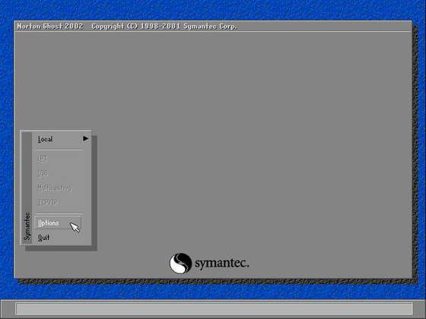
Depending on how you wish to store your ghost image, you may wish to use the options to specify media size (eg cd-rom = 650 or 700mb). Another way of performing this action is to start ghost using command line switches.
Shown below is an example intended to split the ghost image into 640mb chunks, suitable for cd-rom storage :
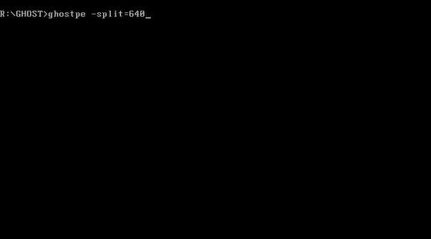
Important considerations.
In order to make a ghost image of your hard disk, you will need space on a separate hard drive or partition, equal to the size of the space currently taken up by your operating system and software. Even if you intend to archive the ghost image to cd-rom, you will temporarily need hard disk space to write the image.
Because you must boot from an ms-dos boot disk, which does not understand NTFS partitions, the separate drive or partition which you are going to use must be formatted using the FAT32 file system.
If you are using Windows NT4, 2000 or XP, and you have formatted your C: drive as NTFS, then you will not be able to directly see that partition through ms-dos, although ghost will be able to work with the partition just fine.
Due to this limitation in ms-dos, when you go to save your image file, the partition or drive which is normally your D: drive, may appear as C: in ghost. Do not worry about this, as when you reboot to your OS, it will return to D:
This limitation in ms-dos does not cause a problem if all your drives are formatted as FAT32, as they would be if you use Windows 98 or ME.
If you are happy that such a drive or partition exists, and that you have adequate free space, then you can start telling ghost what to make an image of.
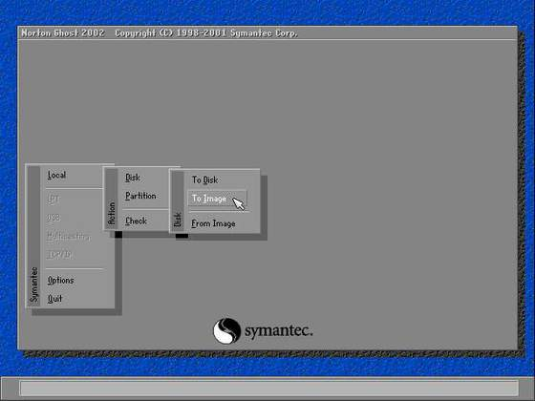
We start the imaging process by clicking on the following menu items in sequence :
Local => Partition (or Disk) => To Image.
- You would use "Disk => To Image" if you wished to image an entire drive, or a drive which only contained one partition.
- You would use "Partition => To Image" if you wished to image only one of the partitions on a hard disk, i.e if you had used FDISK or Partition Magic to physically split your hard disk into two separate drives .. for example C: & D:
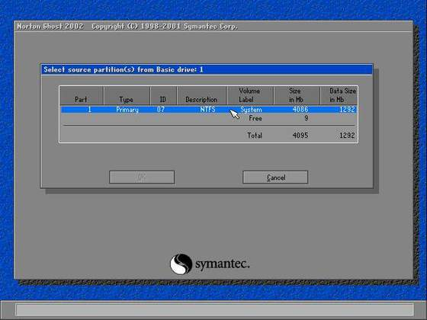
From the above screenshot, you can see that we are selecting the primary (and only) partition on this hard disk. You may notice that because the drive is formatted using NTFS, there is no reference to a drive letter. If your source partition is formatted using FAT32, then the drive letter will be visible here.
Once you have selected the drive or partition which you wish to image, ghost will ask you where you wish to create the image.
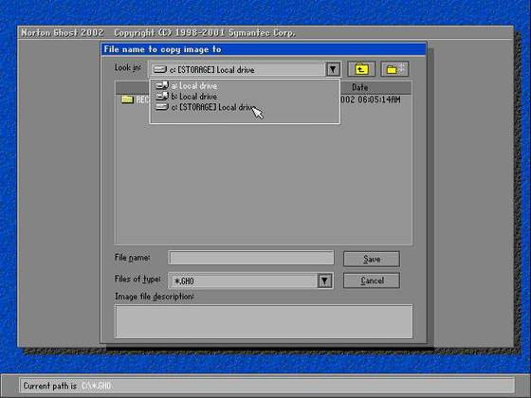
As you can see from the above screenshot, we are going to save the ghost image on our C: drive, which in actuality, is the D: drive, but since ms-dos cannot "see" our real C: drive because it is NTFS, it substitutes the second drive or partition to the C: drive letter because it is the only available or useable hard disk or partition. Again, i have to stress that this issue is only prevalent for those using a Windows NT / 2000 / XP system running NTFS.
prev< | >next

Making an image of your hard disk using Norton Ghost - Page 3
Next thing that we need to do is give the ghost image a name for easy identification.
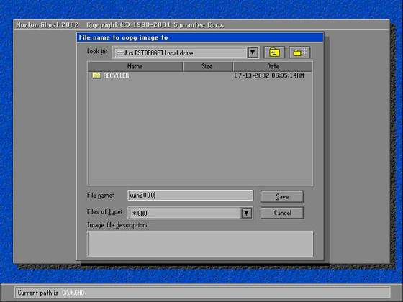
This part of the process is as simple as saving any document or file, but one thing to remember is that ms-dos is limited to a filename length of 8 characters, so it will reject any lengthy filenames such as : "backup copy of my windows 2000 install.gho"
When you click save, the next dialog you will be presented with, offers to compress the image file, so that you can save some disk space :
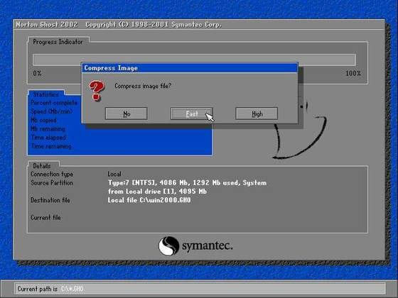
Using compression is up to you. Using no compression will make the image in the shortest space of time, but will yield the largest file. Conversely, using the highest level of compression will create a significantly smaller file, but will take the longest period of time to create. I personally tend to use the "fast" compression method, which gives you the best of both worlds.
When you have decided on the compression method that best suits you, simply click on the associated button, and ghost will than present you with this dialog :
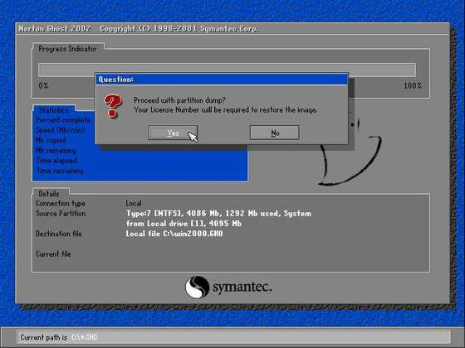
Basically, all ghost is asking is "are you sure". If you are happy that you've got everything right so far, then just click "yes"
- The "License Number" warning displayed in the above screenshot is there simply because of the version of ghost which i am using in this tutorial. I purchased Ghost Personal Edition direct from Symantec at a cost of $50 US Dollars. Money well spent IMO.
Once you click yes, ghost will start to create and compress your image file :
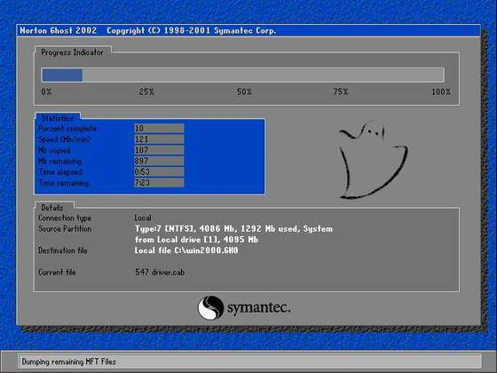
Depending on the size of your partition or hard disk, this process may take from 10 to 30 minutes to complete.
Once the imaging is complete, ghost will present you with the following dialog :
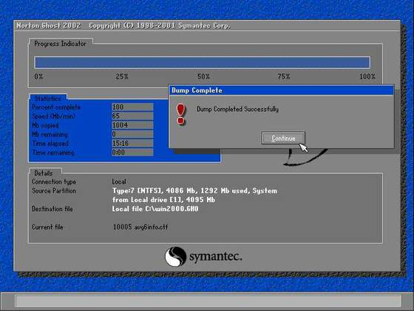
And thats it! Click Continue, and exit out of ghost, or reboot if it gives you that option. Make sure you remove any floppy disks from the drive, and your pc should restart normally.
You may wish to change your boot priority back to it's previous settings thorough the BIOS to prevent it from inadvertently attempting a floppy boot.
prev< | >next

Making an image of your hard disk using Norton Ghost - Page 4
Once you have rebooted back into your normal operating system, all that is left to do, is check that the ghost image is present, using windows explorer, and move it to either cd-rom, or a network share.
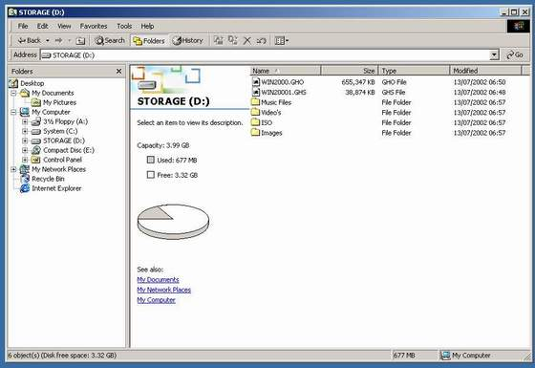
As you can see, our win2000.gho file is here, along with an additional file using the GHS extension.
The reason there is more than one file is because at the start of the imaging procedure, we chose to split the image up into chunks to that we could store it on cd-rom. The win2000.gho file should fit perfectly onto one 650mb cdr, while the win2000.ghs file will happily fit onto a second disk with plenty of space to spare.
4. Final Considerations
When you use ghost to make an image of your hard disk, it copies everything into the image file.
If you store any personal data - such as word documents, or e-mails on the drive which you are going to image, those documents will also be included in the ghost image.
This unfortunately means, that if you have a severe system crash 6 months down the line, and you need to restore from the ghost image that you have prepared, any documents contained in your folders eg. My Documents, will be 6 months old.
I recommend that you store your personal data either on another drive, or partition, or even a cdrw disk. Apart from the fact that you will prevent the ghost image from being bloated by endless gifs / jpgs / mp3's / docs etc, the image that you create, will be purely the OS, installed drivers & applications. This is often known as a "build".
Words & Pictures by Technical Support @ Bitbendertech.
prev< | >next

Or can visit the link for: http://www.bitbenderforums.com/forums/showthread.php?45411-Making-an-image-of-your-hard-disk-using-Norton-Ghost

