<OBJECT ID="MediaPlayer" WIDTH=328 HEIGHT=247
Window Media player html code one
http://www.streamalot.com/wm-embed.shtml
classid="CLSID:22D6F312-B0F6-11D0-94AB-0080C74C7E95"
codebase="http://activex.microsoft.com/activex/controls/mplayer/en/nsmp2inf.cab#Version=6,4,7,1112"
standby="Loading"
type="application/x-oleobject">
<PARAM NAME="FileName" VALUE=" File should be here.wmv">
<PARAM NAME="ShowControls" VALUE="1">
<PARAM NAME="ShowDisplay" VALUE="0">
<PARAM NAME="ShowStatusBar" VALUE="0">
<PARAM NAME="AutoSize" VALUE="0">
<PARAM NAME="autoStart" value="False">
<PARAM NAME="BufferingTime" value="6">
<Embed type="application/x-mplayer2"
pluginspage="http://www.microsoft.com/windows/windowsmedia/download/"
filename="splash.wmv"
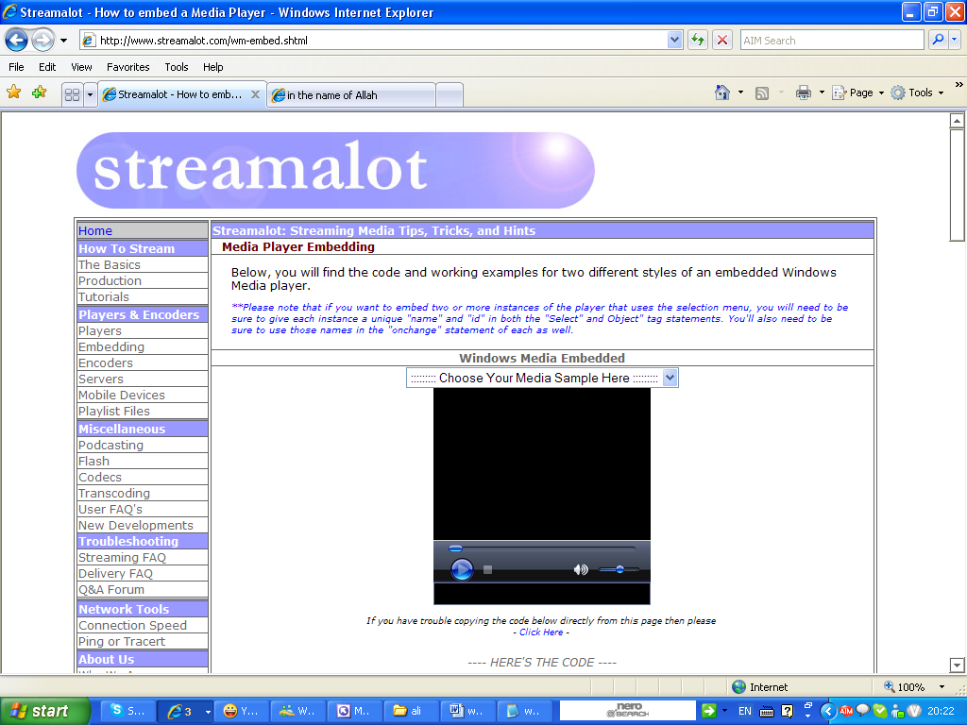
src="splash.wmv"
Name=MediaPlayer
ShowControls=0
ShowDisplay=0
ShowStatusBar=0
width=320
height=240>
</embed>
</OBJECT>

<object id="MediaPlayer1" width=180 height=50
classid="CLSID:22D6F312-B0F6-11D0-94AB-0080C74C7E95"
codebase="http://activex.microsoft.com/activex/controls/mplayer/en/nsmp2inf.cab#Version=5,1,52,701"
standby="Loading Microsoft® Windows® Media Player components..."
type="application/x-oleobject" align="middle">
<param name="FileName" value="Dr_Jebril.wmv" />
Window Media player html code Two
<param name="AutoStart" value="True" />
<param name="ShowStatusBar" value="True" />
<param name="DefaultFrame" value="mainFrame" />

<!-- BEGIN PLUG-IN HTML FOR FIREFOX-->
<embed type="application/x-mplayer2"
pluginspage = "http://www.microsoft.com/Windows/MediaPlayer/"
src="Stream URL or Full File Path Goes Here" align="middle"
width=176
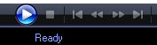
height=144
defaultframe="rightFrame"
showstatusbar=true>
</embed>
<!-- END PLUG-IN HTML FOR FIREFOX-->

</object>
<!-- END GENERIC ALL BROWSER FRIENDLY HTML FOR WINDOWS MEDIA PLAYER -->

<br />
<a href="Stream URL or Full File Path Goes Here">Click here for standalone player</a>
Code for Single File Player
Code for Multi-File Player some time True can be -1 when do not want Auto play put 0
Window Media player html code Three
<SELECT name=selecta size=1 id=musica onchange=document.all.playera.Filename=document.all.musica.value;>
<OPTION selected>::::::::: Choose Your Media Sample Here :::::::::</OPTION>
<OPTION value="Stream URL or Full File Path Goes Here">My Video File </OPTION>
<OPTION value="Stream URL or Full File Path Goes Here">My Audio File</OPTION>
<OPTION value="Stream URL or Full File Path Goes Here">My Live Stream</OPTION>
</select>
<BR>
<OBJECT id=playera height=230 width=230 classid=clsid:22D6F312-B0F6-11D0-94AB-0080C74C7E95>
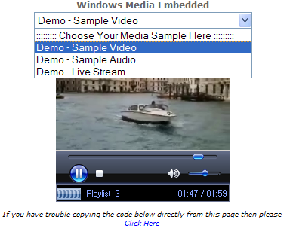
<PARAM NAME="AutoStart" VALUE="True">
<PARAM NAME="Balance" VALUE="False">
<PARAM NAME="DisplaySize" VALUE="True">
<PARAM NAME="Filename" VALUE="File should be here">
<PARAM NAME="Mute" VALUE="False">
<PARAM NAME="SelectionStart" VALUE="False">
<PARAM NAME="SelectionEnd" VALUE="False">
<PARAM NAME="ShowControls" VALUE="True">
<PARAM NAME="ShowAudioControls" VALUE="True">
<PARAM NAME="ShowDisplay" VALUE="False">
<PARAM NAME="ShowPositionControls" VALUE="False">
<PARAM NAME="Volume" VALUE="1">
<PARAM NAME="AudioStream" VALUE="False">
<PARAM NAME="AutoSize" VALUE="False">
<PARAM NAME="AnimationAtStart" VALUE="False">
<PARAM NAME="AllowScan" VALUE="False">
<PARAM NAME="AllowChangeDisplaySize" VALUE="False">
<PARAM NAME="AutoRewind" VALUE="True">
<PARAM NAME="BaseURL" VALUE="">
<PARAM NAME="BufferingTime" VALUE="5">
<PARAM NAME="CaptioningID" VALUE="">
<PARAM NAME="ClickToPlay" VALUE="True">
<PARAM NAME="CursorType" VALUE="0">
<PARAM NAME="CurrentPosition" VALUE="True">
<PARAM NAME="CurrentMarker" VALUE="True">
<PARAM NAME="DefaultFrame" VALUE="mainframe">
<PARAM NAME="DisplayMode" VALUE="1">
<PARAM NAME="Enabled" VALUE="-1">
<PARAM NAME="EnableContextMenu" VALUE="False">
<PARAM NAME="EnablePositionControls" VALUE="False">
<PARAM NAME="EnableFullScreenControls" VALUE="False">
<PARAM NAME="EnableTracker" VALUE="False">
<PARAM NAME="InvokeURLs" VALUE="False">
<PARAM NAME="Language" VALUE="False">
<PARAM NAME="PlayCount" VALUE="1">
<PARAM NAME="PreviewMode" VALUE="False">
<PARAM NAME="ShowStatusBar" VALUE="True">
<PARAM NAME="TransparentAtStart" VALUE="True">
</OBJECT>
Real player link

<object width=320 height=240 classid=clsid:CFCDAA03-8BE4-11cf-B84B-0020AFBBCCFA>
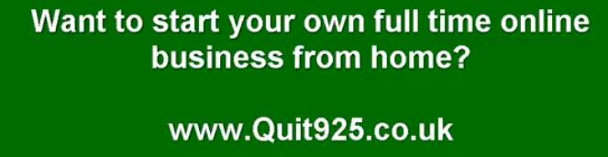
<param value=All name=controls>
<param value=true name=autostart>
<param value=video1 name=console>
<param value=true name=center>
<embed name=myMovie src=http://real.humfak.auc.dk:8080/ramgen/ell/it-vest/TL-190.rm?embed width=320 height=240 pluginspage=http://www.real.com/ controls=All center=true console=video1 autostart=true type=audio/x-pn-realaudio-plugin> </embed>
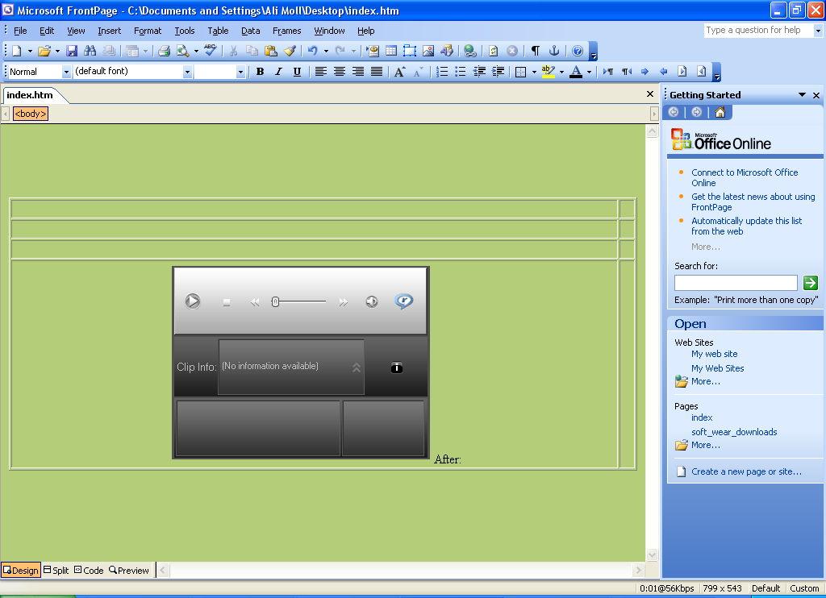
</object>

Two link
<object width=320 height=240 classid=clsid:CFCDAA03-8BE4-11cf-B84B-0020AFBBCCFA>
<param value=All name=controls />
<param value=true name=autostart />
<param value=video1 name=console />
<param value=true name=center />
<embed width=320 height=240 name=myMovie src=http://real.humfak.auc.dk:8080/ramgen/ell/it-vest/TL-190.rm?embed pluginspage=http://www.real.com/ controls=All center=true console=video1 autostart=true type=audio/x-pn-realaudio-plugin />
</object>
YouTube autoplay

Need to add the &autoplay=1 in the blue area where I have add for your video you can copy and pest in your web site
Example one

<object width="480" height="385"><param name="movie" value="http://www.youtube.com/v/73oeo7Pu0tE&hl=en_GB&fs=1&rel=0&color1=0x006699&color2=0x54abd6&autoplay=1"></param><param name="allowFullScreen" value="true"></param><param name="allowscriptaccess" value="always"></param><embed src="http://www.youtube.com/v/73oeo7Pu0tE&hl=en_GB&fs=1&rel=0&color1=0x006699&color2=0x54abd6&autoplay=1" type="application/x-shockwave-flash" allowscriptaccess="always" allowfullscreen="true" width="480" height="385"></embed></object>
-----------------------------------------------------------------------------------------------------------
YouTube video automatically play link
Example Two

<object width="120" height="100"><param name="movie" value="http://www.youtube.com/v/Mel_1EoaOXQ&hl=en_GB&fs="></param><param name="allowFullScreen" value="true"></param><param name="allowscriptaccess" value="always&autoplay=1"></param><embed src="http://www.youtube.com/v/Mel_1EoaOXQ&hl=en_GB&fs=1&autoplay=1" type="application/x-shockwave-flash" allowscriptaccess="always" allowfullscreen="true" width="120" height="100"></embed></object>
-----------------------------------------------------------------------------------------------------------
For You Tube video you can make the window small or big as below link
YouTube video
<object type="application/x-shockwave-flash" allowscriptaccess="always" width="150" height="150" align="middle" data="http://ak.webfetti.com/assets/toys/F/184.swf"><param name="allowScriptAccess" value="always"><param name="movie" value="http://ak.webfetti.com/assets/toys/F/184.swf"><param name="loop" value="true"><param name="quality" value="best"><param name="bgcolor" value="#ffffff"><param name="wmode" value="transparent"></object> <br><center><a style="font-family: Arial;font-size:1px;" href="http://www.mlsisland.com">sell my house fast</center></a>
------------------------------------------------------------------------------------------------
<object type="application/x-shockwave-flash" allowscriptaccess="always" width="150" height="150" align="middle" data="http://ak.webfetti.com/assets/toys/F/188.swf"><param name="allowScriptAccess" value="always"><param name="movie" value="http://ak.webfetti.com/assets/toys/F/188.swf"><param name="loop" value="true"><param name="quality" value="best"><param name="bgcolor" value="#ffffff"><param name="wmode" value="transparent"></object><br><center><a style="font-family: Arial;font-size:1px;" href="http://www.mlsisland.com">sell house fast san diego</a></center>
------------------------------------------------------------------------------------------------------------
<object type="application/x-shockwave-flash" allowscriptaccess="always" width="150" height="150" align="left" data="http://ak.webfetti.com/assets/toys/F/180.swf"><param name="allowScriptAccess" value="always"><param name="movie" value="http://ak.webfetti.com/assets/toys/F/180.swf"><param name="loop" value="true"><param name="quality" value="best"><param name="bgcolor" value="#ffffff"><param name="wmode" value="transparent"></object><br><center><a style="font-family: Arial;font-size:1px;" href="http://www.mlsisland.com">flat fee mls</a></center>

clock html
http://www.worldtimeserver.com/clocks/wtsclock001.aspx
http://www.24webclock.com/en/
best clock html for web site
http://www.timeanddate.com/clocks/free.html
clock web site
http://www.free-flash-clock.info/?gclid=CLXj8P-4k5oCFYKB3godjmu1Mw
clock Html

<a href="http://www.mlsisland.com/cash-for-cars-san-diego.html" title="sell your car san diego" target="_blank"><p align="center"><embed src="http://www.respectsoft.com/onlineclock/ballclock.swf" width="125" height="125" quality=high pluginspage="http://www.macromedia.com/shockwave/download/index.cgi?P1_Prod_Version=ShockwaveFlash" type="application/x-shockwave-flash" wmode="transparent"></embed><br></a>
clock Html
<div align="center" style="width:150px;text-align:center;">
<a href="http://www.midwestwatches.com" title="watches"><object classid="clsid:d27cdb6e-ae6d-11cf-96b8-444553540000" codebase="http://fpdownload.macromedia.com/pub/shockwave/cabs/flash/swflash.cab#version=6,0,0,0" width="150" height="150" id="watch1" align="middle">
<param name="allowScriptAccess" value="sameDomain" />
<param name="wmode" value="transparent" />
<param name="movie" value="http://lib.store.yahoo.net/lib/swissarmypro/watch1.swf" /><param name="quality" value="high" /><param name="bgcolor" value="#ffffff" /><embed src="http://lib.store.yahoo.net/lib/swissarmypro/watch1.swf" quality="high" bgcolor="#ffffff" wmode="transparent" width="150" height="150" name="watch1" align="middle" allowScriptAccess="sameDomain" type="application/x-shockwave-flash" pluginspage="http://www.macromedia.com/go/getflashplayer" />
</object></a>
<br>
<a style="font-family: Arial;font-size:1px;" href="http://www.mlsisland.com/cash-for-cars-san-diego.html">cash 4 cars san diego ca</a>
</div>

This short code can be use in emergency
For Device Manger: Run – devmgmt.msc
Creating a custom Microsoft console tools: Run – mmc
System information tool: Run – msinfo32.exe
File signature verification utility: Run – sigverif.exe
Find computer IP address: Run – cmd – click ok then ipconfig

How do I find my computer manufacturer?
Click Start, click Run, type msinfo32, and then click OK. Your computer manufacturer is listed as the System Manufacturer in the right pane of the System Information window.

Follow the below guidance to change you windows key
- click start
- click Run
- in the Run type: regedit
- Click Ok
- In the left pane, locate and then click the following registry key: HKEY_LOCAL_MACHINE
- Software
- Microsoft
- WindowsNT
- Current Version
- WPAEvents
- In the right pan right click OOBETimer and click Modify change at least one digit of this value to deactivate Windows
- Click Start and then click Run
- In the open box type the following command and then click Ok. %systemroot%\system32\oobe\msoobe.exe /a
- Click Yes, I want to telephone a customer service representative to activate Windows, and then click next.
- Click change product key.
- Type the new product key in the new key boxes and then click update.
- If you are returned to the previous window, click reminds me later and then restart the computer repeat steps 6 and 7 to verify that windows is activate. You receive the following message: windows is already activate. Click Ok to Exit.
- Click Ok
- Install windows XP SP1 or a later version of Windows XP.
- If you can not restart windows after you install windows XP SP1 or a later version of windows XP press F8 when you restart the computer select last known good
- Configuration and then repeat this procedure.
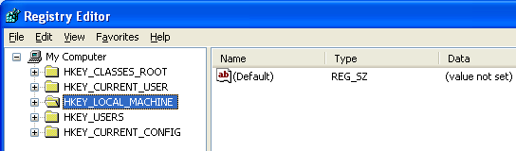
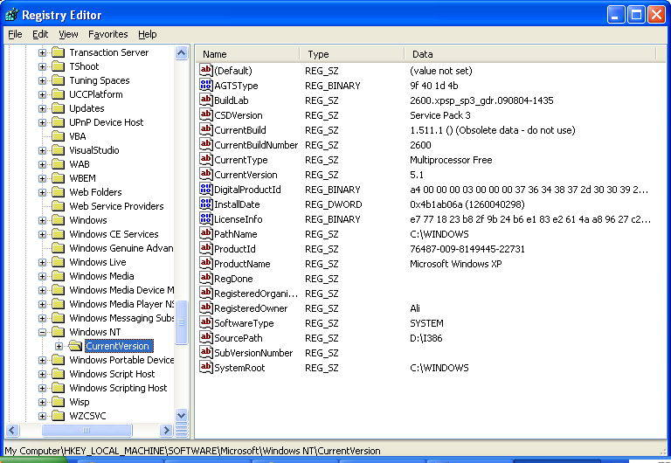

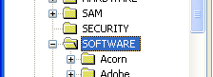
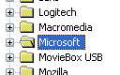
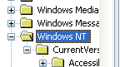
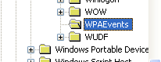
------------------------------------------------------------------------------------------------------------

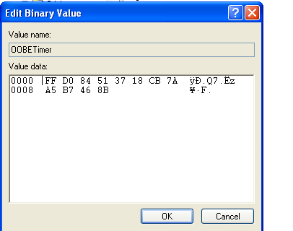
--------------------------------------------------------------------------------------------------------
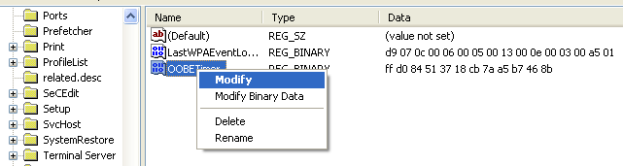

How To Change the Windows XP Product Key
March 7, 2008 by tech84 If for some reason you might wanna change you current WinXP CD Key or after you discover your current key is pirated or illegal but you don’t want to reinstall Windows XP to activate your new legal key
Here’s how:
1. Click on Start and then Run.
2. In the text box in the Run window, type regedit and click OK. This will open the Registry Editor program.
3. Locate the HKEY_LOCAL_MACHINE folder under My Computer and click on the (+) sign next the folder name to expand the folder.
4.Continue to expand folders until you reach the HKEY_LOCAL_MACHINE\Software\Microsoft\WindowsNT\Current Version\WPAEvents registry key.
5.Click on the WPAEvents folder.
6.In the results that appear in the window on the right, locate OOBETimer.
7.Right-click on the OOBETimer entry and choose Modify from the resulting menu.
8. Change at least one digit in the Value data text box and click OK. This will deactivate Windows XP.
9. Click on Start and then Run.
10. In the text box in the Run window, type the following command and click OK.
%systemroot%\system32\oobe\msoobe.exe /a
12. When the Windows Product Activation window appears, choose Yes, I want to telephone a customer service representative to activate Windows and then click Next.
13.Click Change Product Key.
14.Type your new, valid Windows XP product key in the New key text boxes and then click Update.
15. If you’re taken back to the previous screen and prompted, choose Remind me later.
16. Restart your PC.
download
isohunt.com

http://www.brothersoft.com/downloads/azuras.html

http://www.deansoft.com/
Search for web site
<form method="get" action="http://www.google.com/search">
<input type="text" name="q" size="15"
maxlength="100" value="" />
<input type="submit" value="Shaar Malekan Search" />
<input type="radio" name="sitesearch" value="" />
The Web
<input type="radio" name="sitesearch"
value="askdavetaylor.com" checked /> Ask Dave Taylor<br />
</form>
Photoshop Guide

http://simplephotoshop.com/photoshop_tools/index.htm

any time hand tools get frez need to hold down the shift key and drag on page .

