i cant update my windows xp computer

http://support.microsoft.com/kb/2606456

Step 1: Close all running programs
Close any programs that you have running on your computer including any Internet Explorer or other web browser windows and then continue to step 2.

Step 2: Enable Automatic Updates
To enable Automatic Updates, follow these steps:
- Click Start, and then click Run.
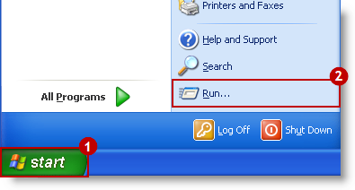

- Type sysdm.cpl, and then click OK.
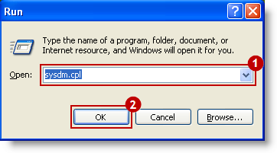

- Click the Automatic Updates tab, click Automatic (Recommended), and then click OK.
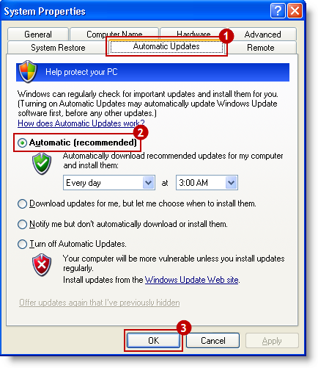

Step 3: Ensure a self-update happens right away
- Click Start, and then click Run.

- Type wuauclt/detectnow, and then click OK.
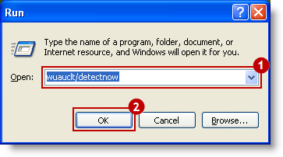

Note: If you do not wish to leave Automatic Updates turned on, you can repeat the steps in Step 2 and the set Automatic Updates to one of the following:
- Download updates for me, but let me choose when to install them.
- Notify me but don't automatically download or install them.
- Turn off Automatic Updates.
If this method does not resolve the problem, go to Method 2.
Back to the top | Give Feedback

Method 2: Install Windows Update Agent 3.0

Step 1: Download Windows Update Agent 3.0

- Click the following link to download the Windows Update Agent 3.0 installation file.
  - Windows XP SP2:http://download.windowsupdate.com/v7/windowsupdate/redist/standalone/WindowsUpdateAgent30-x86.exe
  - Windows XP SP3:http://download.windowsupdate.com/WindowsUpdate/redist/standalone/7.4.7600.226/WindowsUpdateAgent30-x86.exe

To determine which version of the service pack that you are running, follow these steps:
1. Click Start.
2. Click My computer, and then right-click Properties.
3. Under System, you can see the version of the service pack that you are running

- In the File Download - Security Warning dialog box, click Save.
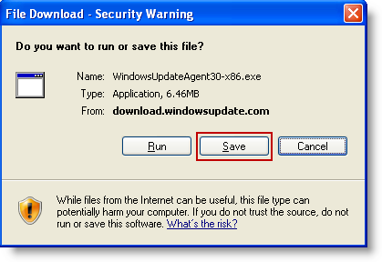

- Select Drive C in the drop-down list, and then click Save.
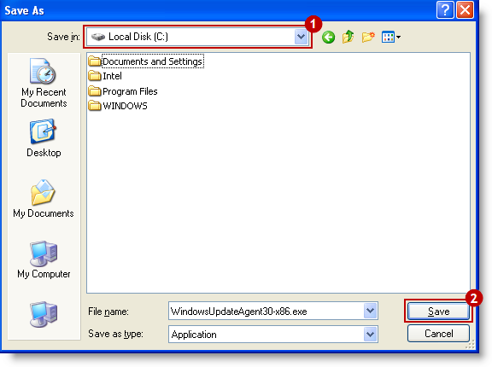

Do not change the file name when you save the file.

Step 2: Install Windows Update Agent 3.0
To install Windows Update Agent 3.0, follow these steps:
- Click Start, and then click Run.

- Type C:\WindowsUpdateAgent30-x86.exe /wuforce, and then click OK.
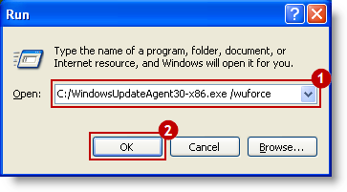

- In the Open File-Security Warning window, click Run.
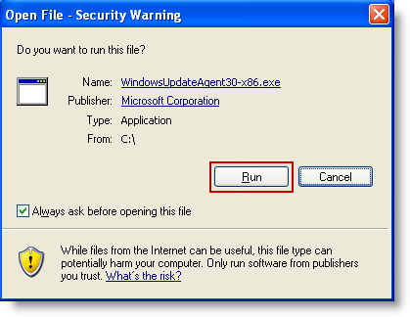

- In the Windows Update Agent Installer window, click Next.
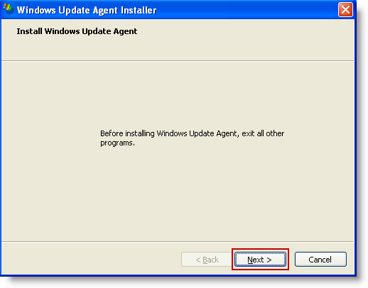

- Select the Accept check box, and then click Next.
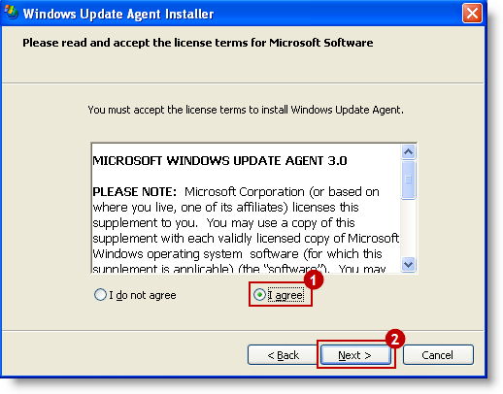

- Click Finish when the installation is complete. Check whether the problem is fixed.
