For passport pictures size
- Bring pictures
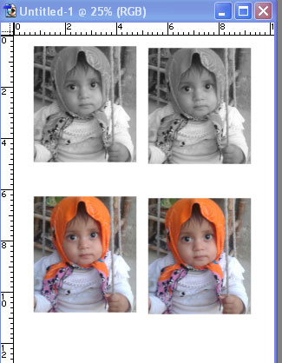
- Width: 3.5CM
- Height: 4.5CM
- Resolution: 300
- Pixels
- Use Crop Tool to size picture Press Enter
- Sharp picture: Ctrl + L
- select pictures: Ctrl + A
- Copy picture: Ctrl + C
- File – New – Preset: photo
- Size: 4x6
- Width: 3.5CM
- Height: 4.5CM
- Resolution: 300
- Pest picture: Ctrl +V
- To repeat picture: Ctrl +J
- Copy all pictures now: Ctrl +Alt + A
- Then: Ctrl + E
- Ctrl +J
- Ctrl + E
- Click rectangular Marquee tool then choose four pictures together from top to bottom
- Ctrl + Shift + U to make half of picture Black and white
- Ctrl + D

